**Assignment 6**

1. **What are the various elements of the Excel interface? Describe how they're used.**

Files : This interface is used to open new file, save, save as file, Create new file

Home : Used to display main screen where you can perform activities.

Insert : User can use this interface to insert any thing which is inside excel or stored in outer storage space

Page layout : You can edit page dimensions, outlook, and things related to any page specifications.

Formula Bar: The formula bar is located above the worksheet area and displays the content of the active cell. You can use the formula bar to enter or edit data, formulas, or functions in the selected cell.

View Buttons: In the bottom-right corner of the Excel window, you'll find three view buttons: Normal View, Page Layout View, and Page Break Preview. These buttons allow you to switch between different views for better visualization and editing of your data.

Ribbon: The ribbon is a collection of tabs, each containing groups of related commands organized by functionality. It replaced the traditional menu system and makes it easier to access various Excel features.

Quick Access Toolbar: The Quick Access Toolbar is a customizable toolbar located above the ribbon or below it, depending on your preference. It provides quick access to frequently used commands like Save, Undo, Redo, and others. You can add or remove commands to suit your needs.

1. **Write down the various applications of Excel in the industry**

* Data Entry and Storage.
* Performing Calculations.
* Data Analysis and Interpretation.
* Reporting and Visualizations.
* Accounting and Budgeting.
* Collection and Verification of Business Data.
* Calendars and Schedules.
* Administrative and Managerial Duties

1. **On the ribbon, make a new tab. Add some different groups, insert**

**commands in the groups and name them according to their commands**

**added. Copy and paste the screenshot of the steps you followed.**

Step 1 :

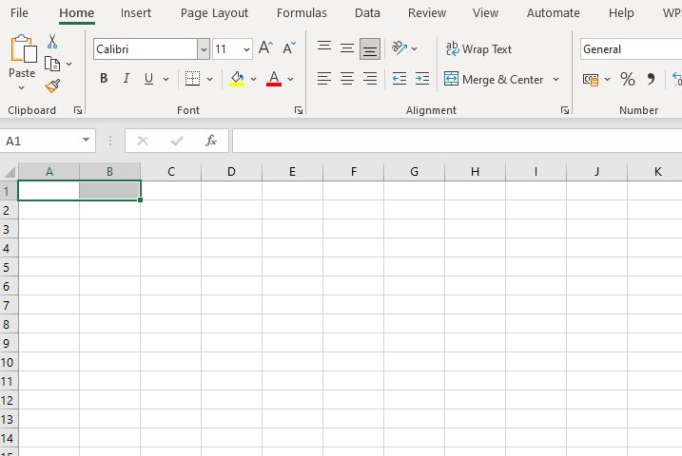

Click on Merge & Center option.

Step 2 :

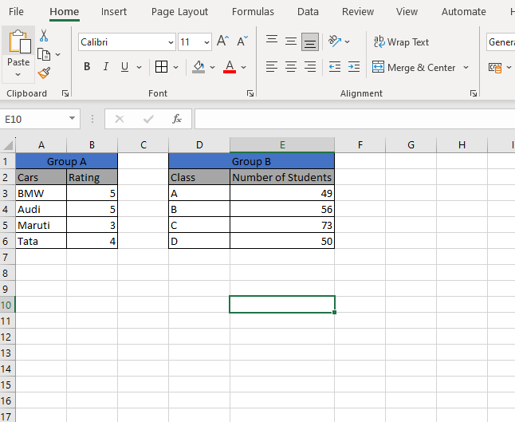

Enter data and select which cell you want to highlight then select color option

1. **Make a list of different shortcut keys that are only connected to**
2. **formatting with their functions.**